CLASSIFIED
Copy _____ of _____
1st Battalion, 7th Cavalry Regiment
1st Armored Brigade Combat Team
1st Cavalry Division
111820CMAR18
FRAGMENTARY ORDER (FRAGO):
JUNIPER SPEAR
HBCT TO BATTALION OPERATIONS PLAN
REFERENCES:
- Area of Operation Overlay
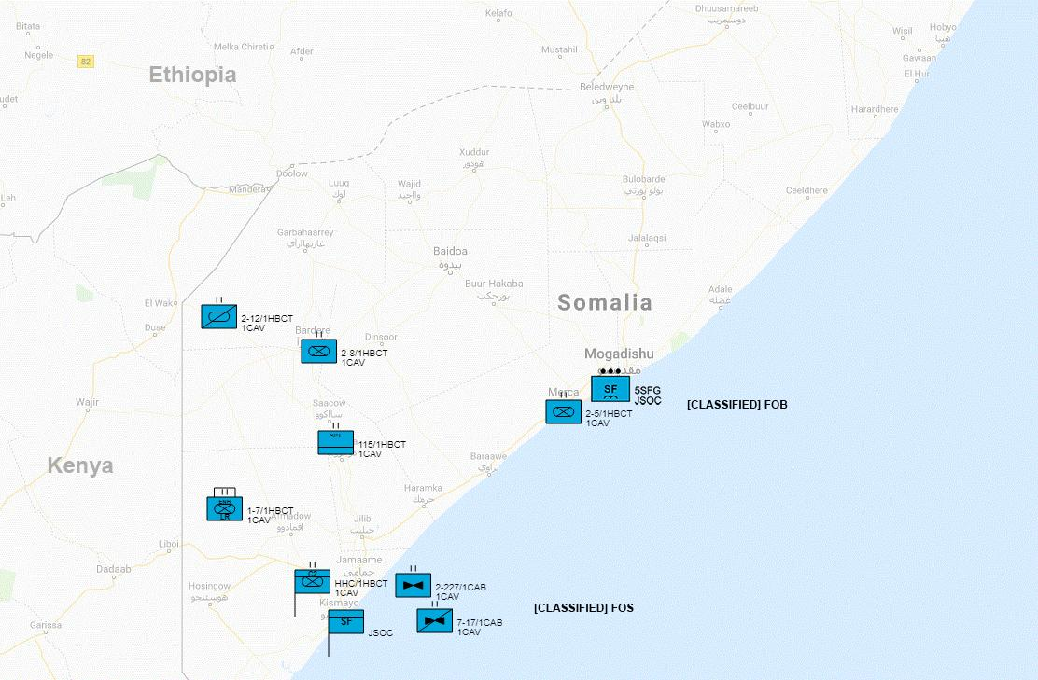
- Area of Interest Overlay - Desert
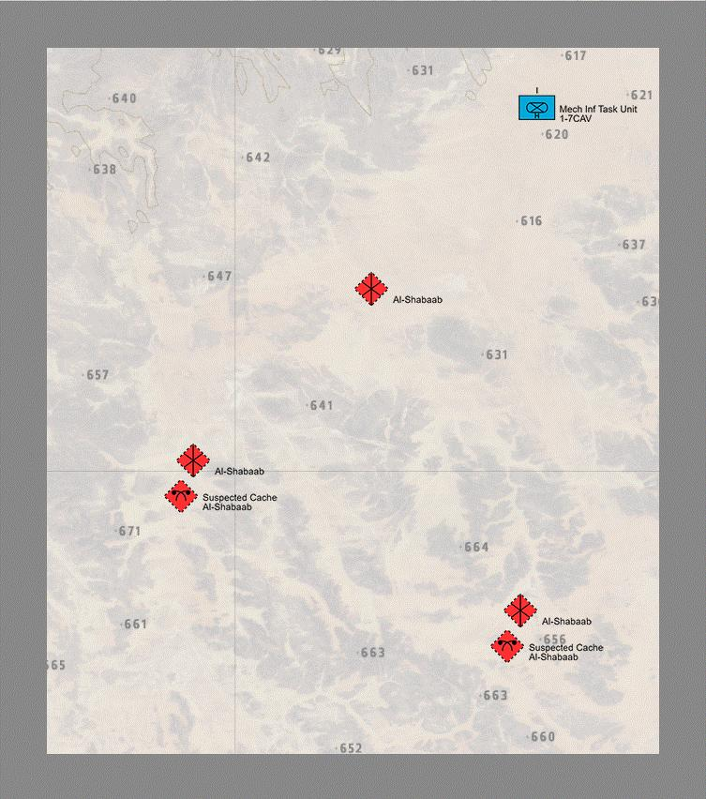
- Area of Interest Overlay - Jungle
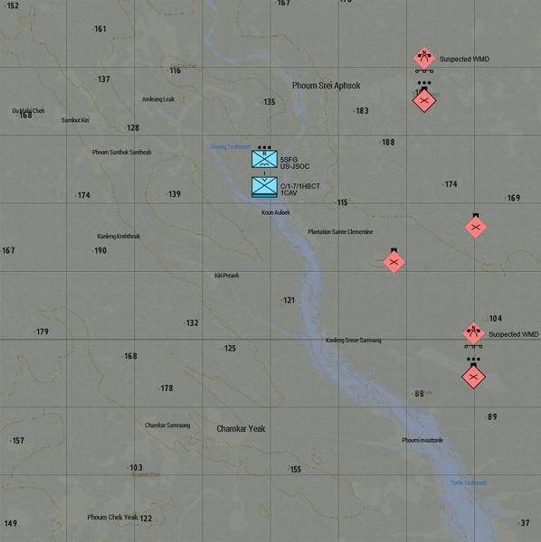
- SITUATION.
Ahmad Umar (Umar), leader of Al-Shabaab in Somalia has eluded BLUFOR by escaping Mogadishu, and taking the WMDs with him. Brigade HHC received reports from US-JSOC that Umar and the WMDs slipped between 115 BSB and 2-5 CAV’s position, then past them towards the Kenyan border. JSOC intel indicates Umar is making a run for the Kenyan border. While in transit, Umar’s convoy broke off into two section, one heading towards the desert and the other into the jungle. 1-7 CAV is being immediately re-tasked with pursuing Umar and the WMDs, and catching them both before reaching the Kenyan border. 2-5 CAV will be taking over Mogadishu for stability operations.
  - General. No change.
    - Assessment of the Conflict.
Rather then detonate the devices in Mogadishu, Umar has (wisely) chosen to escape and take the WMDs with him. Being intimately familiar with the terrain, and guided by his seasoned guards, Umar was able to slip past US and SNSF forces to the south-west towards the Kenyan border. Upon reaching the city of Afmadow, and before US-JSOC could intercept his convoy, it split into two sections, with one heading due east from there in the desert, and the other moving south-east into the jungle. Both the desert and jungle convoys then split again, with each section heading to separate encampments (See Overlays 2 and 3). US-JSOC therefore believes there are four possible locations that Umar and the WMDs will be temporarily located, before being moved again into Kenya.
It is believed that Umar will be unable to detonate the WMDs while on the move, therefore the Brigade must find and intercept him before he reaches his final destination.
    - Policy Goals
      - US/Multinational Policy Objectives. No change.
      - End State.
The desired end-state of this operation is to eliminate the threat of Ahmad Umar, or any other affiliated terrorists, from utilizing the captured nuclear warheads as a WMD.
    - Non-US National Strategic Decisions. No change.
    - Operational Limitations. No change.
  - Area of Concern
    - OA
The Operational Area (OA) is Somalia.
No change.
    - Area of Interest
The area of interest for phase two of Operation Juniper Spear are the regions due east and south east of Afmadow, Somalia.
Afmadow is a city in southern Somalia, located in the middle of the Juba region and bordered by Kenya, Badhadhe, Kismayo, Jamame, Jilib, Hagar, Bardhere and Elwaq in Somalia, 401km southwest of the capital (Mogadishu). The region to the direct east and north of Afmadow is desert, while the region to the south and south east is jungle.
Weather in the region is estimated to have high temps of 42°, low temps of 25°, partly sunny and very warm.
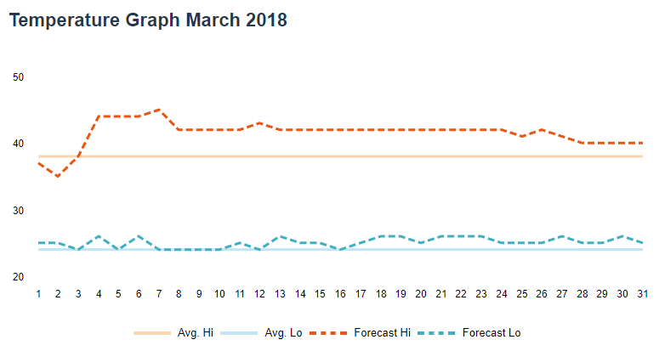
  - Deterrent Options.
No deterrent options are available at this time.
  - Risk
The primary risk to the CJTF-HOA, and population of the Horn of Africa generally, is the detonation of the two nuclear warheads by Ahmad Umar, or an affiliate. Specifically now that Umar and the WMDs are on the move, there is a heightened threats to neighboring Kenya.
  - Enemy Forces
The primary enemy force within the Area of Interest is Al Shabaad. See Annex B [Intelligence] for details.
No change.
The named leader of the group is Ahmad Umar.
    - Enemy Center of Gravity (COGs)
      - Strategic. No change.
      - Operational
The Enemy's operational COG is the desert east, and jungle south east of Afmadow, Somlia. Umar is using Al Shabaad encampments to shelter while in transit towards Kenya.
    - Enemy Critical Factors
      - Strategic
Al Shabaads strategic COG are the south-western regions of Somalia, and eastern region of Kenya. Umar is fleeing towards his stronghold. There are likely thousands of Al Shabaab fighters in the region who are intimately familiar with the terrain.
      - Operational
Umar, the WMDs, and encampments will be heavily fortified by large numbers of Al Shabaab fighters. Their encampments will be deeply entrenched. Al Shabaab groups will likely establish ambush and quick response sites throughout the area.
    - Enemy COAs
      - General
Umar is on the run, in an attempt to flee into Kenya. He has reached the edges of Al Shabaab held territory, and has split his convoy into four different subsections to evade capture. The convoys have just reached encampments and have not moved from there, as of yet. They will likely leave soon. When pursued, Umar will likely continue to run. Al Shabaab fighters will staunchly defend Umar, as well as due everything they can to slow down, and stop, his pursuit.
      - Enemy’s End State
It is believed Umar is fleeing to Kenya and will likely attempt to re-establish his dominance once he’s consolidated and re-constituted his forces.
      - Enemy’s Strategic Objectives
Intelligence estimates indicate the enemy’s strategic objective is to reach an Al Shabaab stronghold in Kenya where he can hide himself and the WMDs. Umar wants to hold onto the WMDs, and live to fight another day.
      - Enemy’s Operational Objectives
The enemy’s current operational objectives are to evade capture and to re-supply before heading across the Kenyan border.
      - Enemy CONOPs
The enemy’s concept of operation is to split up, hide, re-supply, then make a run for the Kenyan border.
    - Enemy Logistics and Sustainment
Al Shabaab has numerous encampments throughout the Area of Interest. They are deeply entrenched and well supplied. Their supplies are coming mostly from Kenya.
    - Other Enemy Forces / Capabilities
Insurgents in the OA are generally motorized and lightly armed, although many are augmented by CSW.
    - Enemy Reserve Mobilization
Kenyan Army and CJTF-HOA intelligence suggest Al Shabaab forces in Kenya are amassing to link up and support Umar’s retreat.
  - Friendly Forces
    - No change.
    - Friendly COGs
      - Strategic
        - Camp Lemonnier, Djibouti (CJTF-HOA).
        - Headquarters and Headquarters Company (HHC) will be based at FOS [Classified] Kismayo, along with US-JSOC.
      - Operational
        - 1-7 CAV (CAB) [Enhanced Task Force] will be on the move east and south-east of Afmadow.
        - 2-5 CAV (CAB) will occupy and be based at FOB Jazeerah, Mogadishu, along with 5th SFG.
        - 2-8 CAV (CAB) will remain FOB [Classified], Bardere, along with SNSF
        - 2-12 CAV (ARS) will be on the move conducting reconnaissance in force along the northern border of Kenya and Somalia.
        - 115 BSB will remain in place at the logistics hub at FOB [Classified], Haramka, along with SNSF.
        - 2-227 AVN (General Support) will remain in place at FOS [Classified], Kismayo, along with HHC,7-17th CAV, and US-JSOC.
        - 7-17 CAV (Attack Reconnaissance) remain in place at FOS [Classified], Kismayo, along with HHC, 2-227th AVN, and US-JSOC.
    - Friendly Critical Factors
      - Strategic
        - Keep Umar and the WMDs from escaping.
        - Disrupt Al Shabaab forces in south-western Somalia.
      - Operational
        - Find and neutralize WMDs quickly, and avoid prolonged conflict as it will lead to increased likelihood of WMD usage.
        - Avoid civilian casualties.
    - Multi-National Framework. No change.
    - Supporting Command and Agencies
      - US-JSOC has surveillance capabilities from FOS [Classified], Kismayo.
      - Non-essential / non-combat SNSF and Somali Federal Government personnel are not present in the Afmadow region given the heavy Al Shabaab presence there.
  - Assumptions
    - Threat Warning / Timeline.
OPFOR pose an immediate threat. They are on the run from Mogadishu, and have made it to the edge of heavily occupied Al Shabaab territory. OPFOR will likely initiate contact via ambush, will staunchly defend their territory and leader, and will utilize terrain knowledge and fortifications to their advantage.
    - Pre-Positioning / Regional Access.
There are no SNSF units in the region. US-JSOC is providing limited security throughout the region, although 1ABCT-1CAV is responsible primarily for its own security.
    - In-Place Forces.
There are no SNSF forces in the AO. Kenyan Army forces are positioned along their side of the border.
OPFOR is pre-positioned throughout the region and surrounding areas. See Overlays for details.
    - Strategic Assumptions.
OPFOR will likely hold position, and utilize guerrilla style tactics in defense of their encampments. OPFOR will likely be reinforced from the west (Kenya). Umar is unlikely to detonate WMDs, although preparation for an event, along with CBRN capabilities to handle the WMDs when captured will be required.
  - Legal Considerations
    - ROE. Strict ROE applies for contact with all civilians. Civilians may be armed. Engage only in self-defense, unless mission parameters dictate otherwise.
    - International Law (inc. Law of War). No change.
    - US law. No change.
    - HN and partner nation policies. No change.
    - Status of forces agreements. No change.
    - Other bilateral treaties and agreements. No change.
    - HN agreements to include HNS agreement. No change.
- MISSION
1-7 CAV is to move immediately from Mogadishu to Afmadow, where it will establish a hasty Battalion Command Post. From there, it will move it’s Air Assault Task Unit to the south of Afmadow, and its Mechanized Infantry Task Unit to the west in search of Umar and the WMDs. Both Task Units will reconnaissance in force two suspected encampments where Umar’s convoy from Mogadishu split off and has stopped at.
- EXECUTION
  - Initial Commander's Intent.
1-7 CAV is to leave Mogadishu in the hands of 2-5 CAV and pursue Umar and the WMDs before they reach Kenya.
  - Concept of Operations.
    - Phases.
      - Deployment. 1-7 CAV will deploy to Afmadow and establish a hasty Battalion Command Post.
      - Reconnaissance in Force. 1-7 CAV will reconnaissance in force the jungles south and deserts west of Afmadow and ensure the position of the OPFOR encampments is confirmed.
      - Breakthrough. 1-7 CAV will move to contact Al Shabaab forces in the AO, pushing through them towards the known encampments.
      - Exploitation. 1-7 CAV will find and neutralize the WMDs and Umar.
    - Primary Maneuver Elements. No change.
    - Fire Support. No change.
  - Tasks to Maneuver Units. No change.
  - Tasks to Combat Support Units. No change.
  - Coordinating Instructions.
    - HHC to establish hasty Battalion Command Post at Afmadow, Somalia.
    - All other coordinating tasks to be determined at the Task Unit level, via OPORD.
- SERVICE SUPPORT
  - General.
    - Sustainment operations will be coordinated with 115th BSB, Haramka.
    - Resupply will be coordinated with 115th BSB, Haramka.
    - Battalion CCP (Surgical Center) will be based at hasty BN CP (Afmadow).
    - Special medical instructions - Ensure all personnel are checked for radiation exposure. Ensure proper setup for CBRN.
  - Materials and Services.
    - Supply: No change.
    - Transportation. No change.
    - Services. All services to be setup at Battalion Command Post.
    - Maintenance. No change.
  - Medical Evacuation.
    - Medical evacuation in field will be handled by 2-227th AVN (aeromedical evacuation) to battalion field hospital at Afmadow.
    - Medical evacuation for critical / mortally wounded will be handled by 115 BSB via ground and air transportation with support of 2-227th AVN to logistics hub, and then to FOS [Classified], Kismayo.
  - Personnel.
    - Reinserts will be brought back to Battalion Command Post (Afmadow) from 115 BSB logistics hub via 2-227 AVN.
    - EPWs are to be detained, searched, and cleared of all weapons and equipment, then consolidate at FOB Jazeerah for transport to FOS [Classified], Kismayo.
  - Miscellaneous. N/A.
- COMMAND AND SIGNAL
  - Command.
    - HHC 1ABCT is based out of FOB [Classified], Kismayo.
    - Battalion CP located at Afmadow.
    - Succession of Command.
      - Battalion Commander
      - Battalion Executive Officer
      - Battalion Sergeant Major
      - S3 Officer in Charge
    - Adjustments to the unit SOP. None.
  - Signal. No change.

ACKNOWLEDGE: COL A. Grgich
Commanding

Table X. List of Attachments and responsible staff officers
Annex | Responsible Officer | Included / Omitted
ANNEX A - TASK ORGANIZATION | S-3 | Omitted. See Section 3(c) of WARNO.
ANNEX B - INTELLIGENCE | S-2 | Included
ANNEX C - OPERATIONS | S-3 | Omitted. TBD based on future missions.
ANNEX D - FIRES | Fire Support Officer | N/A
ANNEX E - PROTECTION | Chief of Protection | Omitted. Brigade echelon.
ANNEX F - SUSTAINMENT | S-4 | Omitted. Brigade echelon.
ANNEX G - ENGINEER | Engineer Officer | Omitted. TBD based on future missions.
ANNEX H - SIGNAL | S-6 | Omitted. Brigade echelon.
ANNEX I - Not Used
ANNEX J - PUBLIC AFFAIRS |  | Omitted. See Brigade Campaign Plan.
ANNEX K - CIVIL AFFAIRS OPERATIONS | S-9 | Omitted. See Brigade Campaign Plan.
ANNEX L - INFORMATION COLLECTION | S-3 | Omitted. See Section III.B.1(b) of WARNO.
ANNEX M - ASSESSMENT | S-3 | Omitted. Brigade echelon.
ANNEX N - SPACE OPERATIONS | Space Operations Officer | Omitted. Brigade echelon.
ANNEX O - Not Used
ANNEX P - HOST NATION SUPPORT | S-4 | Omitted. Brigade echelon.
ANNEX Q - KNOWLEDGE MANAGEMENT | Knowledge Management Officer | Omitted. Brigade echelon.
ANNEX R - REPORTS | S-3, S-5, and Knowledge Management Officer | Included.
ANNEX S - SPECIAL TECHNICAL OPERATIONS | Special Technical Operations Officer | Omitted. Brigade echelon.
ANNEX T - Spare
ANNEX U - INSPECTOR GENERAL | Inspector General | Omitted. Brigade echelon.
ANNEX V - INTERAGENCY COORDINATION | S-3 and S-9 | Omitted. Brigade echelon.
ANNEX W - OPERATIONAL CONTRACT SUPPORT | S-4 | Omitted. Brigade echelon.
ANNEX X - Spare
ANNEX Y - Spare
ANNEX Z - DISTRIBUTION | S-3 | Omitted. Brigade echelon.

ANNEX B - INTELLIGENCE
No. _____ of _____
1st Battalion, 7th Cavalry Regiment
1st Armored Brigade Combat Team
1st Cavalry Division
111820CMAR18
ANNEX B (INTELLIGENCE) TO
CAMPAIGN PLAN/ORDER
REFERENCES:
Overlay 1 - See FRAGO.
Time Zone Used Throughout the Plan/Order: East Africa Time Zone (UTC +03:00)
Situation. See FRAGO.
Area of Interest. See FRAGO.
Area of Operations. See FRAGO.
- Terrain. See Task Unit OPORD.
- Weather. See Task Unit OPORD.
- Enemy Forces (Locations / Composition / Disposition). See overlays.
- Friendly Forces. US-JSOC - Provide intelligence through UAV reconnaissance from FOS [Classified], Kismayo, SNSF intelligence gathering, and HUMINT.
- Interagency, Intergovernmental, and Nongovernmental Organizations. None present.
- Civil Considerations. Civilians remain in Afmadow. Many are sympathetic to Al Shabaab. Many are unaware and simply living.
- Attachments and Detachments. None.
- Assumptions.
  - OPFOR is heavily entrenched and fortified.
  - OPFOR will likely use minefields, IEDs, VIEDs, and suicide bombers to prevent movement towards their encampments.
  - OPFOR may use civilians as human shields.
  - Umar and WMDs are in hiding at one of four suspected locations.
ACKNOWLEDGE: SGT K. Schmidtg
S-2 NCOIC
 | MOST WANTED  TERRORIST
Ahmad Umar
Ahmed Omar (Somali: Axmed Cumar, Arabic: أحمد عمر‎), also known as Ahmed Diriye and Abu Ubaidah, is the Emir of the Somalia-based Islamist group Al-Shabaab. He was listed by the US State Department as a Specially Designated Global Terrorist in April 2015.

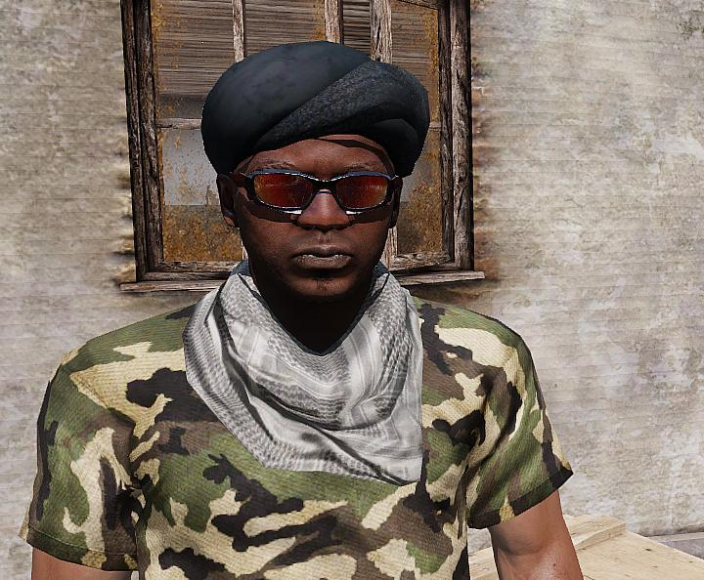

Aliases: Axmed Cumar, Ahmed Diriye, and Abu Ubaidah
Dates of Birth Used: Unknown | Place of Birth: Somalia
Hair: Black | Eyes: Brown
Height: 5’11” | Weight: 195 lbs.
Build: Thin | Complexion: Dark
Sex: Male | Citizenship: Somalia
Languages: English, Unknown | Scars and Marks: Unknown.

REWARD
The rewards For Justice Program, United States Department of State, is offering $6,000,000 for information leading directly to the apprehension or conviction of Ahmad Umar.
REMARKS
He is believed to be in his forties and is a member of the Bajimaal section of the Dir clan from the Kismayo region of Somalia.
SHOULD BE CONSIDERED ARMED AND DANGEROUS
If you have any information concerning this person, please contact your local FBI office or the nearest American Embassy or Consulate.

ANNEX R - REPORTS
No. _____ of _____
1st Battalion, 7th Cavalry Regiment
1st Armored Brigade Combat Team
1st Cavalry Division
111820CMAR18
ANNEX R (REPORTS) TO
CAMPAIGN PLAN/ORDER
REFERENCES:
Overlay 1 - See WARNO.
Time Zone Used Throughout the Plan/Order: East Africa Time Zone (UTC +03:00)
Reports.
- CBRN
  - SUMMARY REPORT OF NUCLEAR DETONATIONS [NUDETSUM]
Use to report information pertaining to nuclear detonations on areas outside the North American continent. This report will support damage assessment at the national level. Reference: FM 3-14.
  - ENVIRONMENTAL CONDITION REPORT [ECR]
Use to send periodic information (interim snapshots) of the environmental status of specific sites (assembly areas, base camps, logistical support areas, and medical facilities) where hazards are likely to occur, which can result in significant, immediate and/or long-term effects on the natural environment and/or health of friendly forces and noncombatants. Send IAW unit SOPs and commander’s direction.
  - SUPPORT-DAMAGE AVOIDANCE AREA [SPRT.DAACAT]
Use (1) to establish nuclear damage categories and (2) to disseminate command guidance establishing chemical avoidance criteria within damage avoidance areas. Reference: FM 3-3-1.
  - NBC 1/ROTA REPORT [NBC1]
Use to provide the observer’s initial report giving basic data on a nuclear attack, biological attack, chemical attack, or releases other than attack (ROTA). This NBC1/ROTA voice message accommodates all NBC1/ROTA reporting. Reference: ATP-45 and FM 3-7.
  - NBC 2/ROTA REPORT [NBC2]
Use to disseminate evaluated data of a nuclear attack, biological attack, chemical attack, or releases other than attack (ROTA). This NBC2/ROTA accommodates NBC2/ROTA (NUC, BIO, or CHEM) reporting requirements. Reference: ATP-45 (A) and FM 3-7.
  - NBC 3/ROTA REPORT [NBC3]
Use to pass immediate warning of predicted contamination and hazard areas following NBC attacks or releases other than attack (ROTA) hazards. This NBC3/ROTA voice message accommodates all NBC3/ROTA (NUC, BIO, or CHEM) reporting requirements. Reference: ATP-45 and FM 3-7.
  - NBC 4 REPORT [NBC4]
Use to report NBC monitoring and survey results. This NBC4 voice message accommodates all NBC4 (NUC, BIO, or CHEM) reporting. Reference: FM 3-7.
  - NBC 5 REPORT [NBC5]
Use to pass information on areas of actual nuclear, biological, or chemical contamination. This NBC5 voice message accommodates all NBC5 (NUC, BIO, or CHEM) reporting requirements by selected use of sets. Reference: FM 3-7.
  - NBC 6/ROTA REPORT [NBC6]
Use to pass detailed information on chemical and biological attacks and releases other than attack (ROTA) hazards. This NBC6/ROTA voice message accommodates all NBC6/ROTA (BIO or CHEM) reporting requirements. Reference: ATP-45 (A) and FM 3-7.
  - DECONTAMINATION REQUEST [DECONREQ]
Use to request decontamination by contaminated units. Initially request on CMD net, then send all traffic through administrative or logistics net. Send initial request with PRIORITY precedence. Reference: FM 3-5.
  - DECON SITE REPORT [DECONSTREP]
Use to update progress and status of decontamination sites in a unit’s area of operation. Submit as required IAW unit SOPs. Transmit on O&I ROUTINE precedence. Reference: FM 3-5.
- RECONNAISSANCE
  - ROUTE REPORT [ROUTEREP]
Use to report results of route reconnaissance. Reference: FM 5-34, FM 17-95, and FM 17-98.
  - SURVEILLANCE AND RECONNAISSANCE PLAN REPORT [SURRECONREP]
Use to report reconnaissance and surveillance plans. Reference: FM 34-2-1.
  - RECONNAISSANCE NICKNAME REPORT [RECON 1]
Use to report additions, changes, or deletions of operation order numbers and associated nicknames for reconnaissance. Reference: FM 34-2-1and FM 101-5.
  - RECONNAISSANCE TRACK REPORT [RECON 2]
Use (1) to submit proposed reconnaissance tracks for mission approval and (2) to modify or delete existing active reconnaissance tracks. Reference: FM 34-2-1 and FM 101-5.
  - RECONNAISSANCE SCHEDULING REPORT [RECON 3]
Use (1) to provide selected and specific data on proposed reconnaissance mission schedules, (2) to make changes to approved schedules, and (3) to inform of CINC/unit intention to fly specific reconnaissance missions. Reference: FM 34-2-1 and FM 101-5.
  - RECONNAISSANCE FOLLOWING REPORT [RECON 4]
Use to provide specific information pertaining to a reconnaissance mission flight. Reference: FM 34-2-1, FM 100-103, and FM 101-5.
  - RECONNAISSANCE EXPLOITATION REPORT [RECCEXREP]
Use to provide an abbreviated imagery interpretation report in a tactical situation
- MISSION
  - WAR CRIME REPORTABLE INCIDENT REPORT [WCRIR]
Use to convey flash traffic to the commander relating to a possible, suspected, or alleged violation of the law of war discovered within the command.
  - PATROL REPORT [PATROLREP]
Use to report information and combat actions obtained on mounted and dismounted patrols. Reference: FM 17-98, FM 17-95, FM 7-92, and FM 34-3.
  - EXPLOSIVE ORDNANCE DISPOSAL SUPPORT [EODSPT]
Use (1) to request explosive ordinance disposal (EOD) support, (2) to report the results of an EOD mission, or (3) to request EOD support to protect designated very important persons. Reference: FM 9-15.
  - MEDICAL SITREP [MEDSITREP]
Use to convey a quick, consolidated medical status report as a snapshot rather than a full report. Reference: FM 8-10-3.
  - SPOT REPORT [SPOTREP]
Use to send information to provide timely intelligence or status regarding events that could have an immediate and significant effect on current planning and operations. Reference: FM 17-15, FM 17-98, and FM 7-7.
  - BATTLE DAMAGE ASSESSMENT REPORT [BDAREP]
Use to provide a timely and accurate estimate of damage resulting from the application of military force, either lethal or non-lethal, against a predetermined objective. Reference: FM 9-43-1.
  - SAEDA REPORT [SAEDAREP]
Use to provide notification of a Subversion and Espionage Directed Against the Army (SAEDA) incident. Reference: FM 34-60 and AR 310-50.
  - PRELIMINARY TECHNICAL REPORT [PRETECHREP]
Use to disseminate initial technical information on captured or acquired foreign material and ordnance. Reference: FM 34-54 and FM 34-60.
  - SEARCH AND RESCUE INCIDENT REPORT [SARIR]
Use to report any situation that may require a search and rescue effort. Reference: FM 1-108 and FM 1-513.
  - SURVIVABILITY REPORT [SURREP]
Use to report the completion of survivability tasks. Survivability tasks include digging, revetment, camouflage, and hardening of buildings. Reference: FM 5-34, FM 5-100, and FM 5-102.
  - ENEMY/PRISONER OF WAR REPORT [EPOW]
Use to convey status and disposition of unit’s EPWs. Send IAW unit SOPs. Reference: FM 19-40.
  - LACE REPORT [LACE]
Used to report status after contact with the enemy.
  - CLOSE AIR SUPPORT SUMMARY [CASSUM]
Use to provide timely reports of close, air-support missions and other information obtained during post-flight aircrew debriefing. Reference: FM 6-71.
  - ACCIDENT REPORT/SERIOUS INCIDENT REPORT [SIR]
Use to convey flash traffic to the commander and command post relating to an accident or serious incident within the command. Use FLASH precedence on CMD nets. For all other stipulations and instructions refer to AR 190-40 (SIR) and AR 385-40 (Accident Report)
  - NBC SITUATION REPORT [NBCSITREP]
Use to report current NBC situation and chemical units’ activity. Send on a scheduled time line IAW unit SOPs, such as 0500, 1100, 1700, and 2300 daily. This is considered routine and is a normal report not indicated in NBC 1 through NBC 6 reports. Reference: FM 3-7.
  - DETAINED CIVILIAN PERSONNEL REPORT [DETAINCIVREP]
Use to provide commander of incidents where the unit has detained civilian personnel. Send IAW unit SOPs. Reference: FM 19-40.
  - ENEMY/FRIENDLY/UNIT MINEFIELD/OBSTACLE REPORT [MINOBREP]
Use to report all obstacles on the battlefield after developing a report. Disseminate information and report to all command posts and units in the area of operation as soon as possible. Reference: FM 90-13-1, FM 20-32, and FM 5-34.
  - AIR SUPPORT REQUEST [AIRSUPREQ]
Use to request preplanned and immediate close-air support, interdiction, reconnaissance, surveillance, escort, helicopter airlift, and other aircraft missions. For expedient hard copy or voice request use DD Form 1972 (Revised) 15 NOV 1994 (see Figure A020) or Sample TACAIR Briefing Form (see Figure A015).
- CAMPAIGN
  - CLOSURE REPORT [CLOSEREP]
Use to inform commander of status of movement and capability of the unit to conduct future operations. Submit upon completion of movement as directed by commander. Reference: FM 71-2 and FM 71-3.
  - OPERATION REPORT [OPREP]
Use to report operational situations, problems, recommended or intended courses of action, and other items not reported elsewhere. Send as determined by higher headquarters or by necessity of subordinate headquarters. Reference: FM 100-15, FM 71-100, and FM 101-5.
  - SLANT REPORT [SLANTREP]
Use to give the commander accurate and routine information regarding status of critical personnel and equipment necessary for the unit’s operation success. Submit when necessary or as directed. The commander designates the information to report during planning or by unit SOPs. Reference: FM 71-2 and FM 71-3.
  - RULES OF ENGAGEMENT AUTHORIZATION [ROEAUTH]
Use to authorize or refuse the implementation of specific rules of engagement. Reference: FM 101-5.
  - REQUEST FOR INFORMATION [RFI]
Use to request information from requesting unit’s command post or other units. Reference: FM 101-5.
  - FRAGMENTARY ORDER [FRAGO]
Use to send timely changes of existing orders to subordinate and supporting commanders while providing notification to higher and adjacent commands. Send FLASH precedence O&I or CMD IAW unit SOPs. Reference: FM 101-5.
  - CLASS IV BULK BARRIER MATERIALS REQUEST [BLKIVREQ]
Use to report a periodic update, forecast, or formal request of Class IV barrier materials a unit requires. Reference: FM 5-102, FM 20-32, and FM 90-7.
  - PERSONNEL STATUS REPORT [PERSTAT]
Use to report the status of the unit’s personnel. Reference: FM 12-6.
  - TRANSPORTATION SUPPORT REQUEST [TRANSSPTREQ]
Use to request transportation support other than airlift support. Reference: FM 701-58.
  - MAINTENANCE SUPPORT REQUEST [MAINTSPTREQ]
Use to request maintenance support. Reference: FM 9-43-1.
  - AVIATION (ARMY ROTARY WING) MISSION/SUPPORT REQUEST [AVIAREQ]
Use to request Army aviation units for support. Send from subordinate units to division/corps aviation cell at the main command post. Reference: FM 1-100 and FM 1-114.
  - OPERATION ORDER [ORDER]
Use to transmit the standard five-paragraph operation order (OPORD) and operation plan (OPLAN) that provide plans, instructions, and directives to subordinate and supporting military organizations. Reference: FM 101-5, FM 71-100, and FM 100-15.
  - UNIT SITUATION REPORT [UNITSITREP]
Use to inform commanders of operational plans, unit readiness, and operational situations or summaries. Reference: FM 100-15, FM 71-100, FM 71-3, and FM 71-2.
  - OPERATIONS PLAN CHANGE [PLANORDCHG]
Use to update or change existing operations plans. (Note: Use FRAGO to change OPORD.) Reference: FM 100-15, FM 71-100, and FM 101-5.
  - SEARCH AND RESCUE (SAR) REQUEST [SARREQ]
Use to request forces to participate in a search and rescue (SAR) mission. Reference: FM 1-108 and FM 1-513.
  - REQUEST CONFIRMATION [REQCONF]
Use (1) to inform the requesting command, tasking authority, and tasked units of actions being taken and (2) to provide additional information about the missions. Use for both preplanned and immediate air-tasking cycles. Reference: FM 100-103 and FM 1-100.
  - OPERATIONS SUMMARY [OPSUM]
Use to provide a commander’s summary of significant operations to the next higher commander. Reference: FM 100-15, FM 71-100, and FM 101-5.
  - COMMANDER’S SITUATION REPORT [SITREP]
Use to keep the commander’s higher and lower staff updated and advised on the reporting commander’s critical situation. Reference: FM 100-15, FM 71-3, and FM 71-2.
  - ROAD CLEARANCE REQUEST [ROADCLRREQ]
Use (1) to request road clearance and movement authority for the movement of outsized or overweight vehicles or (2) for the movement of convoys over a controlled or restricted road network. Reference: FM 100-15, FM 71-100, and FM 701-58.
  - WARNING ORDER [WARNORD]
Use to convey a preliminary notice of an impending order or action. Reference: FM 101-5-1 and FM 101-5.

ACKNOWLEDGE: 1LT J. Argus
S-3 OIC

